Ideation Phase
Empathize & Discover

Date | 01 Nov 2025
Team ID | NM2025TMID03572
Project Name | Laptop Request Catalog Item
Maximum Marks | 4 Marks

Empathy Map Canvas:
In the Empathize & Discover phase, our team explored how employees and IT administrators interact with the Laptop Request Catalog Item system. We observed that users often face difficulties in requesting, tracking, and receiving laptops due to unclear workflows and delayed approvals.Through user interviews and surveys, we identified major frustrations such as lack of real-time updates, confusing approval hierarchies, and uncertainty about request status. Administrators also expressed challenges in managing inventory and ensuring that requests comply with policy and availability.
These insights helped the team better understand user pain points and expectations. Users need a transparent, responsive, and automated system that simplifies laptop requests and approvals while ensuring compliance and accountability.This phase guided the development of a user-friendly catalog workflow that improves communication between employees, managers,and the IT team.
Example:

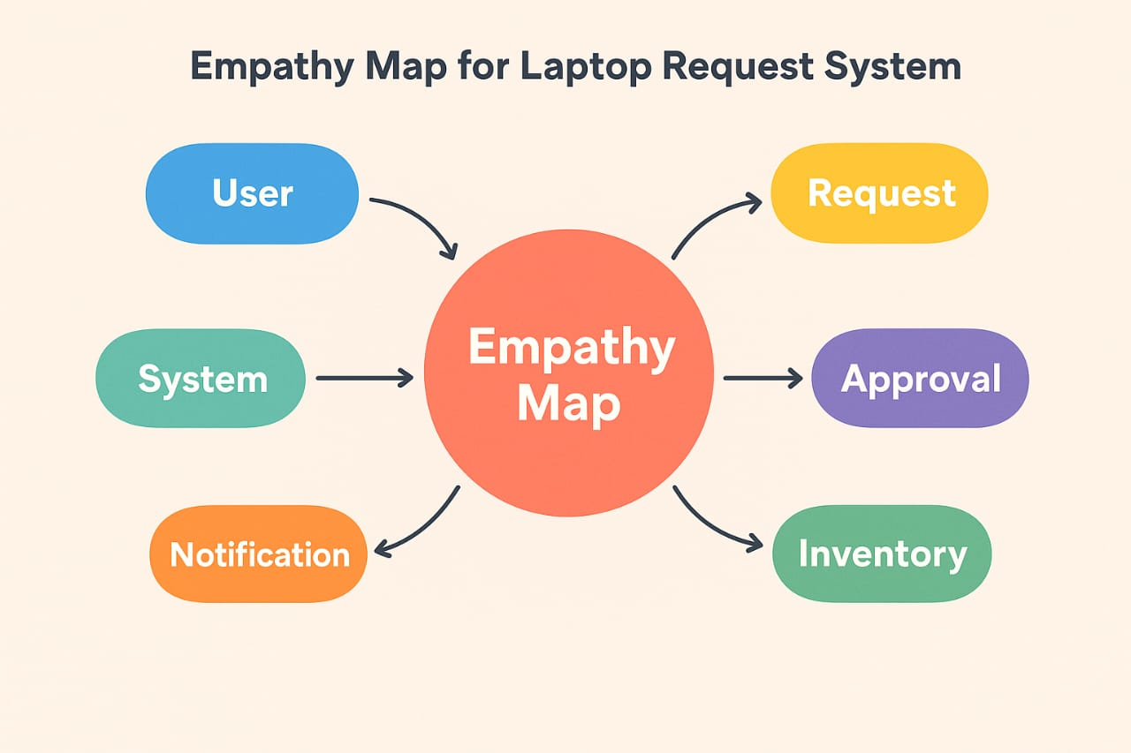

The empathy map helped us understand user challenges when deleting assigned users. It shows their pain, actions, and needs for better control and alerts. This guided us to design a safer system that prevents accidental deletion.

Example:
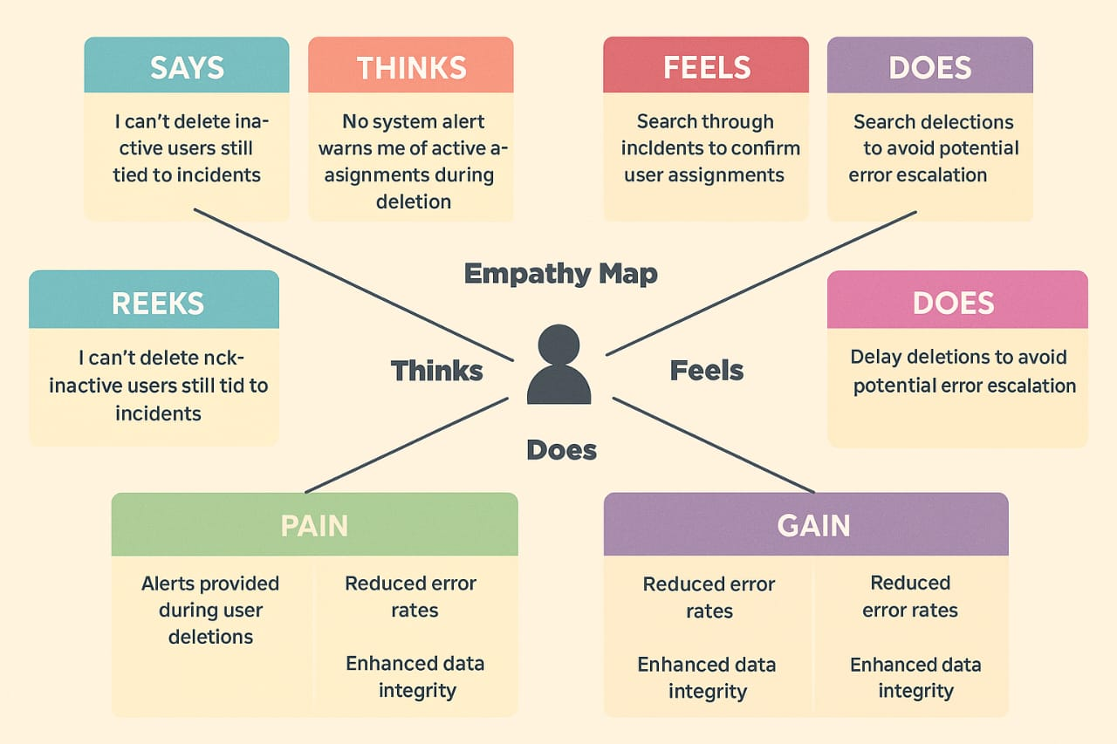
By addressing these user frustrations, the new Laptop Request Catalog Item system will enhance transparency, streamline approval workflows, and automate inventory checks—ensuring faster processing and better user satisfaction.

